**DATA VISUALIZATION CHARTS**

|  |  |
| --- | --- |
| **Team ID** | PNT2022TMID18255 |
| **Project Name** | Corporate Employee Attrition Analytics |

**Story**

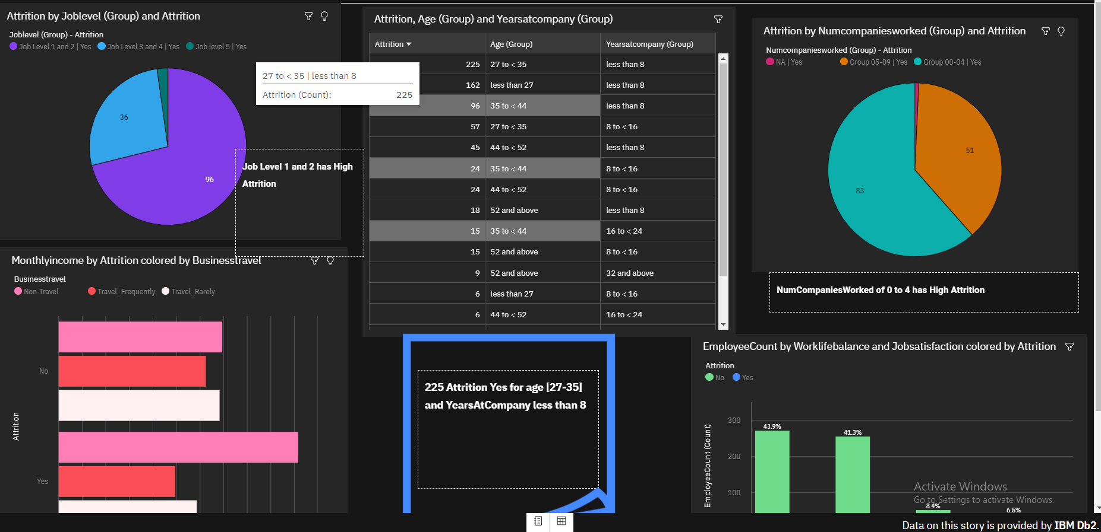

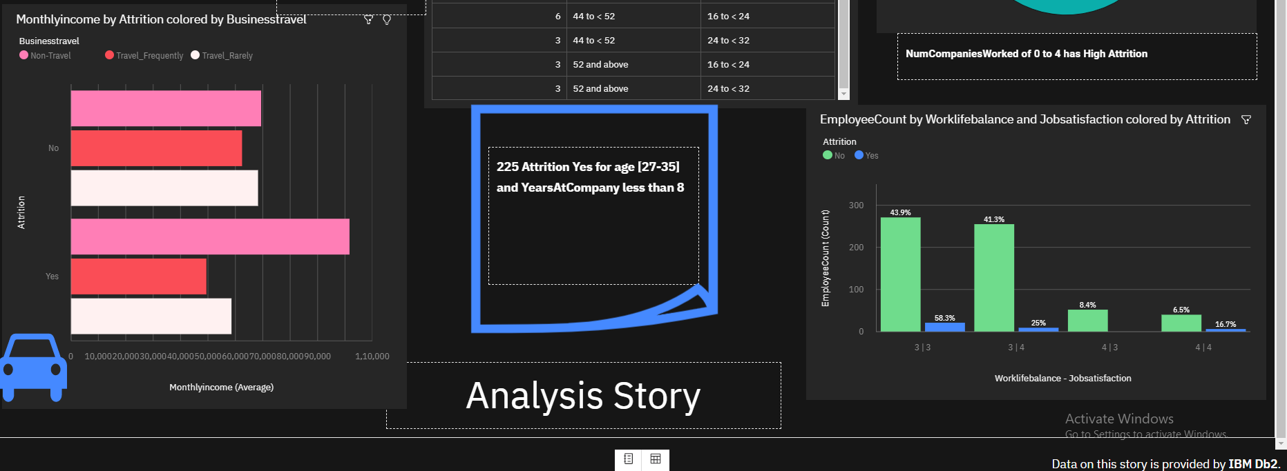

**Story Visualizations**

**Attrition by Joblevel (Group) and Attrition**

**Monthlyincome by Attrition colored by Businesstravel**

**Attrition, Age (Group) and Yearsatcompany (Group)**

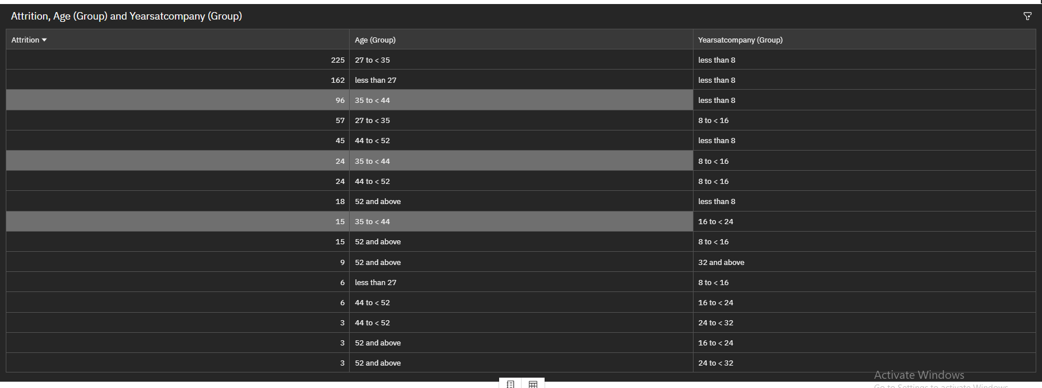

**Attrition by Numcompaniesworked (Group) and Attrition**

**EmployeeCount by Worklifebalance and Jobsatisfaction colored by Attrition**

